

Magenuts IT Solutions Pvt Ltd.

Magento 2 Auto Invoice For Free Order Extension

CONFIGURATION AND SETUP MANUAL

TABLE OF CONTENTS

What’s Magento 2 Auto Invoice For Free Orders .......................................................................................3

Auto Invoice Enable / Disable and Support…………………..............................................................................4

**What’s Magento 2 Auto Invoice For Free Orders**

What’s Magento 2 Auto Invoice For Free Order Magenuts Magento 2 Auto Invoice For Free Order Extension helps Magento 2 admin to generate invoices automatically. Features 1. Fully automate the invoices creating process with Magento 2 Auto Invoice extension. The module will instantly create the invoice as soon as an order is created.

**Important Notes and Requirements**

1. Requirements: **Magento Community 2.1.x up-to 2.3.4, Magento Enterprises (2.1.x to latest).**
2. Server Side Requirements: MySQL 5.0 and above PHP 7.1.6 and above.
3. All functionality is fully tested on Magento Community Edition 2.2.2 and will be compatible withEditions from 2.1.x up to 2.3.4.
4. Magento Enterprises Edition is also supported but not tested.
5. For your safety related to any damage or loss to your store, its strongly recommended to you that take backup first.

**Installation**

1. Unpack the extension ZIP file on your computer.
2. Connect to your website source folder with FTP/SFTP/SSH client and upload all the files and folders from the extension package to the corresponding root folder of your Magento 2.x installation:

|  |
| --- |
| Please use the “**Merge**” upload mode. Do not replace the whole folders, but merge them. This way your FTP/SFTP client will only add new files. This mode is used by default by most of FTP/SFTP clients software. For MacOS it’s recommended to use Transmit. If you install several extensions from Amasty, they will contain same files from the Base package — feel free to overwrite them, these are system files used by all our extensions. |

1. Connect to your Magento directory with SSH.
2. Run the following 3 commands:
3. php bin/magento setup:upgrade
4. php bin/magento setup:static-content:deploy
5. php bin/magento setup:di:compile

**Auto Invoice Enable / Disable Configurations**

At any time you can enable and disable this extension in the system configuration. You can do this by opening the backend menu Stores > Configuration. There you will find the entry Magenuts Extensions > Auto Invoice. After clicking on it you see a dropdown box where you can enable/disable the module. Save the configuration and delete the cache.

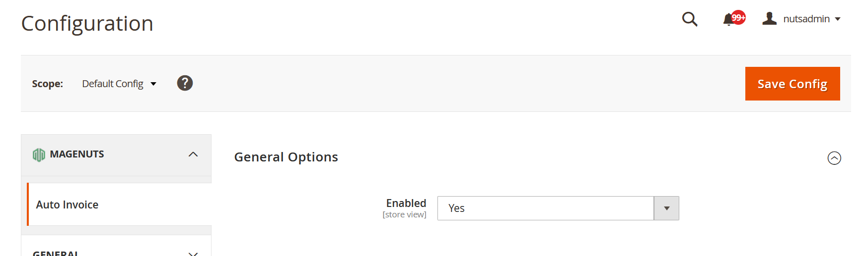

**Support and Customization**

For any support or customization, you can contact us

[support@magenuts.com](mailto:support@magenuts.com)

https://magenuts.com